_{Foundations of Programming}

_{Lab Assignment No. : 03}

_{PROBLEM STATEMENT:}
Write a program in C to generate multiplication tables for a given number.
_{OBJECTIVES:}
- To understand the use of looping statements in C.
- To generate multiplication tables using loops.
- To improve program logic and execution flow understanding.

_{THEORY:}
1. Syntax for for loop example program
Ans. for(initialization ; condition ; increment)
{
_{body;}
}
_{eg. for(int i=1;i<5;i++)}
{
_{printf("%d",i);}
}
2. Syntax for while loop example program
_{Ans. while(condition)}
{
_{Body;}
_{Increment;}
}
_{eg. while(i<5)}
{
_{printf("%d",i);}
_{i++;}
}
3. Syntax for do while loop example program
_{Ans. do {}
_{Body;}
_{increment;}
_{} while(condition);}
_{eg. do {}
_{printf("%d",i);}
_{i++;}
_{} while(i<5);}
_{ALGORITHM:}
_{1. Start}
2. Accept a number from the user and store in 'n'
_{3. Initialize i=1}
_{4. Loop for as long as i<=10}
_{a. Display, "n*i=(n*i)"}
_{b. Increase value of 'i' by 1}
_{5. Stop}
Type Program (Multiplication table)
_{#include<stdio.h>}
_{int main()}
{
_{int n,i;}
_{printf("Enter a number ");}
_{scanf("%d",&n);}
_{for(i=1;i<=10;i++)}
printf("%d * %d = %d \n",n,i,(n*i));
}
_{PLATFORM:}
_{Linux}

_{INPUT:}
_{Choice of number}

_{OUTPUT:}
Displays the multiplication table of the number entered
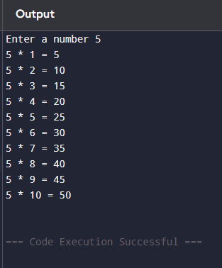
_{SAMPLE INPUT:}
₅
_{SAMPLE OUTPUT:}
_{5 * 1 = 5}
_{5 * 2 = 10}
_{5 * 3 = 15}
_{5 * 4 = 20}
_{5 * 5 = 25}
_{5 * 6 = 30}
_{5 * 7 = 35}
_{5 * 8 = 40}
_{5 * 9 = 45}
_{5 * 10 = 50}
_{CONCLUSION:}
Thus, the loops in C successfully help us print the multiplication table of any number

_{FAQs:}
- Which loop is best suited for generating multiplication tables?
- What is the role of loop initialization?
- Difference between for loop, while loop and do while loop?
- Can a do–while loop be used to generate multiplication tables? Explain.
- Why is the do–while loop called an exit-controlled loop?

